Asian Parliamentary Assembly

SC-Economic/Rep/2015/02
20 August 2015
Report of the Meeting
Standing Committee on Economic and Sustainable Development

19-20 August 2015

Jakarta – Republic of Indonesia

- The Standing Committee on Economic and Sustainable Development held its meeting on 19-20 August 2015 in Jakarta, The Republic of Indonesia. Delegations from 21 APA Member Countries participated in the meeting including Afghanistan, Bahrain, Bangladesh, Bhutan, Cambodia, China, Cyprus, India, Indonesia, Iran, Jordan, Kazakhstan, DPR Korea (representatives of the Embassy), Kuwait, Lao PDR, Malaysia, Maldives, Pakistan, Palestine, the Philippines, and Thailand.. The list of participants is attached as Annex I.

- In inaugural session, Dr. Nurhayati Ali Assegaf, Chairperson of the Committee for Inter-Parliamentary Cooperation the House of Representatives of Indonesia delivered report of the Steering Committee. In her report, Dr. Assegaf stated that APA is an important inter-parliamentary organization. APA serves a forum for its members to discuss important issues, particularly in eradicating poverty, distributing welfare and prosperity for the people. She added "Economy is in uncertainty following the recent financial situation. Financial crisis in one region may affect other region. Therefore, regional cooperation should be put as an important agenda for Asian countries. As a preparation to the meeting, the Indonesian House of Representatives has organized a Focus Group Discussion to gather inputs and capture insights from experts regarding the Asian Parliamentary Assembly and the recent situation in Asia. The Meeting of APA Standing Committee has reached a quorum whereby 21 member countries are participating in the event".

- H.E. Dr. Ali Khorram, Deputy Secretary General of APA on Economic and Sustainable Development presented his opening statement in which he expressed his appreciation for the participations of twenty-one delegations and expressed APA Standing Committee Meeting on Economic and Sustainable Development is one among the three Standing Committees under the APA. During the last eight years, APA has enjoyed much attention from Indonesia that should be appreciated. There are 21 countries participating in this event. He added, Asia is the main producer and consumer of the world's energy. There should be a consistent coordination to ensure the sustainable interests of both suppliers and consumers of energy so the creation of an Asian Integrated Energy Market is a matter of concern. Hon. Khorram mentioned how the environmental impact of energy consumption should be considered and addressed, including its impact on poverty eradication. He said "as we are moving forward from MDGs towards SDGs, robust efforts in sustainable development should be put into reality. APA promotes sustainable economic growth for all Asian countries. Asia has the world's largest economic growth which also affecting other regions. Therefore, it is important to promote international peace and stability". Honorable Dr. Khorram indicated that "the number of participants in the meeting proves the importance of international issues that have been brought into the attention of Asian countries. APA has been able to create opportunities for member parliaments to exchange views and take appropriate decisions based on the interests of Asian countries. Asian countries are expected to support the goal of the APA. APA secretariat looks forward to foster communication with APA member countries". Hon. Khorram highlighted his concern upon the Asian region which was suffering from terrorism. He called all participants of the meeting to stand up for respecting the victims of the terrorism all across Asia including the latest one in Thailand and have a one-minute silence to express their deepest sympathies.

- H.E. Fadli Zon, Vice Speaker of the Indonesian House of Representatives, delivered opening address and officially opened the Meeting. In his opening address, He highlighted the importance of the APA Standing Committee Meeting under the theme "Linking economic growth to SDGs for peace and prosperity" and extended his warm welcome to all delegates. His Excellency emphasized that Asia is rising even stronger as the driver of economic growth. According to qualified sources, even though many countries are still suffering from economic hardship, the real economic growth of Asian countries in the last four years has been promising. In the last two decades, Asian countries have strived to create a more inclusive environment to eradicate poverty. Asian economy is still faced by a number of challenges, such as on income disparities that may hamper security and social stability in the future. Asia produces most of the world's energy sources. Real tangible steps in mitigating climate change should be penetrated into national and regional strategy. Poverty, climate change, and energy sustainability are among the greatest challenges for Asia as the world's largest region. With 4.3 billion population, Asia is a home for 60 percent of the world's inhabitants, putting the continent as the most significant and dynamic region. His Excellency accentuated the need for Asian parliaments to articulate their commitment in advancing peace and prosperity. Through the works of APA, Asian parliaments can produce important resolutions to reinvigorate their political will. It is necessary for Asian parliaments to ensure the successful implementation of SDGs to accelerate sustainable development. Through the series of earlier meeting, APA has developed a number of important resolutions. However, little has really been achieved. APA should re-demonstrate its commitment to be a part of the noble and grand ambition in bringing Asia into prosperity, peace, and friendship.
.
- The meeting started by adopting the agenda and working program drafted by APA Secretariat. Then H.E Mr. Fadli Zon from Indonesia was elected as Chairperson of the Meeting, Hon. Mr. Gul Mohammad Rasoly from Afghanistan was elected as Vice Chairperson, and Hon. Mr. Tenzin Karma from Bhutan was elected as Rapporteur.

- The list of documents before the Meeting included:
  - SC-Economic/Res/2015/05 of 20 August 2015, on Financial Affairs: Ensuring Efforts for Economic Growth
  - SC-Economic/Res/2015/06 of 20 August 2015, on the Role of APA Parliaments to adopt Legislation in Supporting the Implementation of the Sustainable Development Goals
  - SC-Economic/Res/2015/07 of 20 August 2015, on Asian Integrated Energy Market.
  - SC-Economic/Res/2015/08 of 20 August 2015, on Environmental Issues, Global Warming, Climate Change, and Planting Billions of Trees throughout Asia.
  - SC-Economic/Res/2015/09 of 20 August 2015, on Poverty Eradication.

- The Host Parliament also invited expert on international economic, H.E. Dr. Rizal Ramli, Coordinating Minister of Maritime Affairs and Prof. Sudrajad Djiwandono, Professor in International Economics at the S. Rajaratnam School of International Studies (RSIS), Nanyang Technological University of Singapore, to deliver their presentation.
- The Heads of Delegations to the Meeting of APA Standing Committee on Economic and Sustainable Development were given times to deliver general statement addressing the theme of “linking economic growth to sustainable development goals for peace and prosperity”.

- H.E. Dr. Ali Khorram, APA Secretary General on Standing Committee on Economic and Sustainable Development presented reports of APA Secretary General on Integrated Energy Market in Asia; Alleviating Poverty in Asia; Environmental Issues, Global Warming, Climate Change, and Planting Billions of Trees throughout Asia; and International Financial Affairs for the Countries of APA Member Parliaments. The full reports are attached as Annex II.

- The Standing Committee considered and discussed the complete text of each draft resolutions one by one, and made minor alterations to them. It was unanimously decided to recommend the adopted Draft Resolutions to the APA Executive Council Meeting of 2015 to be forwarded to the APA plenary for final consideration and adoption. The Draft Resolutions as follows:

  - SC-Economic/Res/2015/05 of 20 August 2015, on Financial Affairs: Ensuring Efforts for Economic Growth
  - SC-Economic/Res/2015/06 of 20 August 2015, on the Role of APA Parliaments to adopt Legislation in Supporting the Implementation of the Sustainable Development Goals
  - SC-Economic/Res/2015/07 of 20 August 2015, on Asian Integrated Energy Market.
  - SC-Economic/Res/2015/08 of 20 August 2015, on Environmental Issues, Global Warming, Climate Change, and Planting Billions of Trees throughout Asia.
  - SC-Economic/Res/2015/09 of 20 August 2015, on Poverty Eradication.

Resolution on Integrated Energy Market in Asia
The Resolution emphasizes the importance to create an integrated energy market. It is deemed important as Asian countries are the world's largest consumers and producers of energy. Through the mandate of the Advisory Group on Energy, Asian countries shall be able to link demand and supply for energy and further, promote the sustainable use of energy. The Resolution calls upon APA Member Parliaments to encourage the executives in scaling up cooperation among Asian countries on energy-related issues.

Resolution on Environmental Issues, Global Warming, Climate Change, and Planting Billions of Trees throughout Asia
APA highlights the importance of technology transfer and financing environmentally sound technology from developed to developing countries. Further, the Resolution calls upon APA Member Countries to bring as much coordination and collaboration as possible while substantively involved in the on-going negotiations within the context of UNFCCC and Kyoto Protocol. As an addition, the Resolution urges APA Parliaments to support SDGs with regard to environmental issues by formulating and adopting appropriate legislations. As proposed by Indonesia, the Resolution also calls on APA Member Parliaments to urge their respective governments to publish the Intended Nationally Determined Contributions (INDC) prior to the COP21.

Resolution on Poverty Eradication
The Resolution accentuates that each country must take primary responsibility for its own development and that poverty alleviation is important to combat international terrorism, drug trafficking, arms smuggling, human trafficking, and other transnational crimes. The Resolution emphasizes the need to raise awareness on SDGs by utilizing mass media. It further encourages APA Member Parliaments to support the adoption of pro-poor economic policies and invites them to adopt the necessary legislation. As an addition, as proposed by Palestine and Indonesia, the Resolution acknowledges that all acts of aggression and injustice that hinder development and any efforts to achieve sustainable development are not acceptable.

Resolution on Financial Affairs: Ensuring Efforts for Economic Growth
The Resolution deliberates an expression of concerns over the impact of financial markets volatility to the economic growth of APA member countries and the on-going inequality which signified by the growing of Gini Coefficient in Asian economies. The Resolution also acknowledges that peace and stability are catalysts for economic growth. Further, it calls upon APA member countries to formulate new policies and develop comprehensive and innovative growth strategies that would be necessary to build a more resilient, balanced, and sustainable growth. It encourages APA member countries to create a regional protocol for an economic crisis and to invest their sovereign funds as well as private capitals in Asia rather than other parts of the world.

Resolution on the Role of APA Parliaments to Adopt Legislation in Supporting the Implementation of the Sustainable Development Goals
The Resolution underlines the importance of strong political will, leadership, and national ownership of parliaments to meet the commitment towards SDGs. Through the Resolution, APA Member Parliaments demonstrate their determination to be actively involved in the formulation of national policies in supporting the mainstreaming and implementation of SDGs. The Resolution emphasizes the promotion of Human Development Index as an index for the sustainable development goals as well as the Sufficiency Economy Philosophy. APA also requests its Member Parliaments to deliver a report on the achievement of the implementation of SDGs in their respective countries to be discussed in the next meeting of Economic and Sustainable Development Standing Committee.

The Resolutions are attached to this Report as Annex III.

- The Standing Committee carefully considered the complete text of each draft resolutions paragraph by paragraph, and made minor alterations to them. It was unanimously decided to recommend the adopted Draft Resolutions to the APA Executive Council Meeting of 2015, to be forwarded to the APA Plenary for final consideration and adoption.

- The Chair of the Meeting, H.E. Mr. Fadli Zon, Vice Speaker of the House of Representatives of Indonesia delivered a closing remarks and officially closed the Meeting on the second day of the Meeting, the 20th of August 2015. In his closing remarks, His Excellency extended his profound gratitude and appreciation to all delegates for their active participation and invaluable contributions as well as for the kind cooperation in the spirit of amity and cooperation. As a commitment to capture the interests of APA Delegates, His Excellency stated that the report has been able to capture the ideals and ideas reflected in the Meeting. He informed the Meeting that Indonesia will host the 6th Global Conference of the Global Parliamentarian Against Corruption (GOPAC) on the 5th to 8th October 2015 in Yogyakarta, the cultural city in Indonesia, and invite delegates to participate in this Conference.

- The 8th APA Assembly will be held in Phnom Penh, Cambodia in December 2015. The Cambodian Delegation extended their invitation for all Delegates to participate in the Meeting.

- The APA Secretary-General on Standing Committee expressed his appreciation to the House of Representatives of Republic Indonesia for excellent organization of the Meeting and the hospitality extended to all participants. The Committee also commending H.E. Fadli Zon for his able leadership during the duration of this Meeting and to the Deputy Secretary General of APA on Economic and Sustainable Development for the assistance he has provided in the meeting. High appreciation also goes to the staff of local secretariat for their outstanding and effective contribution to the Meeting.

- The Sub-Committee requested the attached draft resolution to be forwarded to the first APA Executive Council meeting of 2010, to be recommended to the APA Plenary for consideration of the Economic Standing Committee.

Annex I
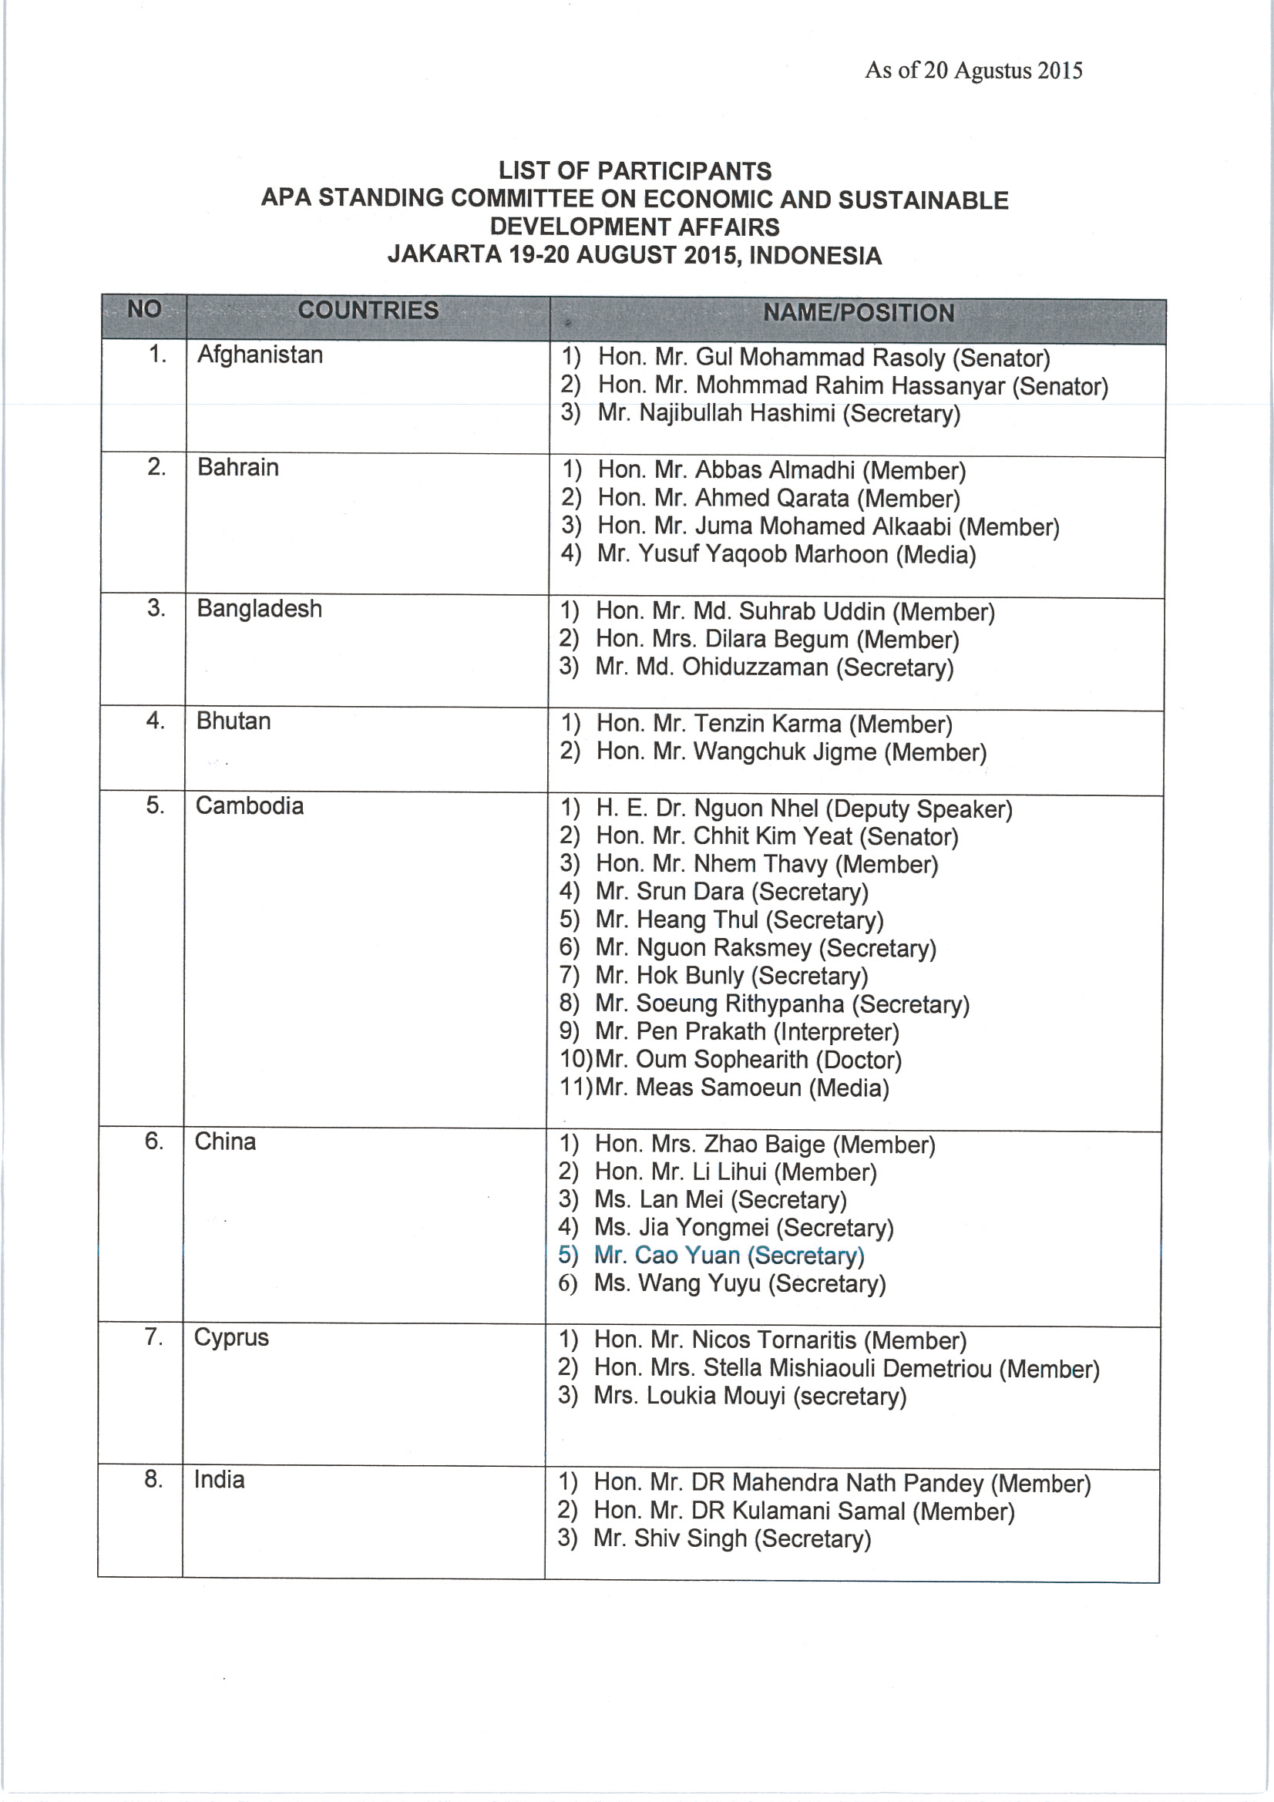
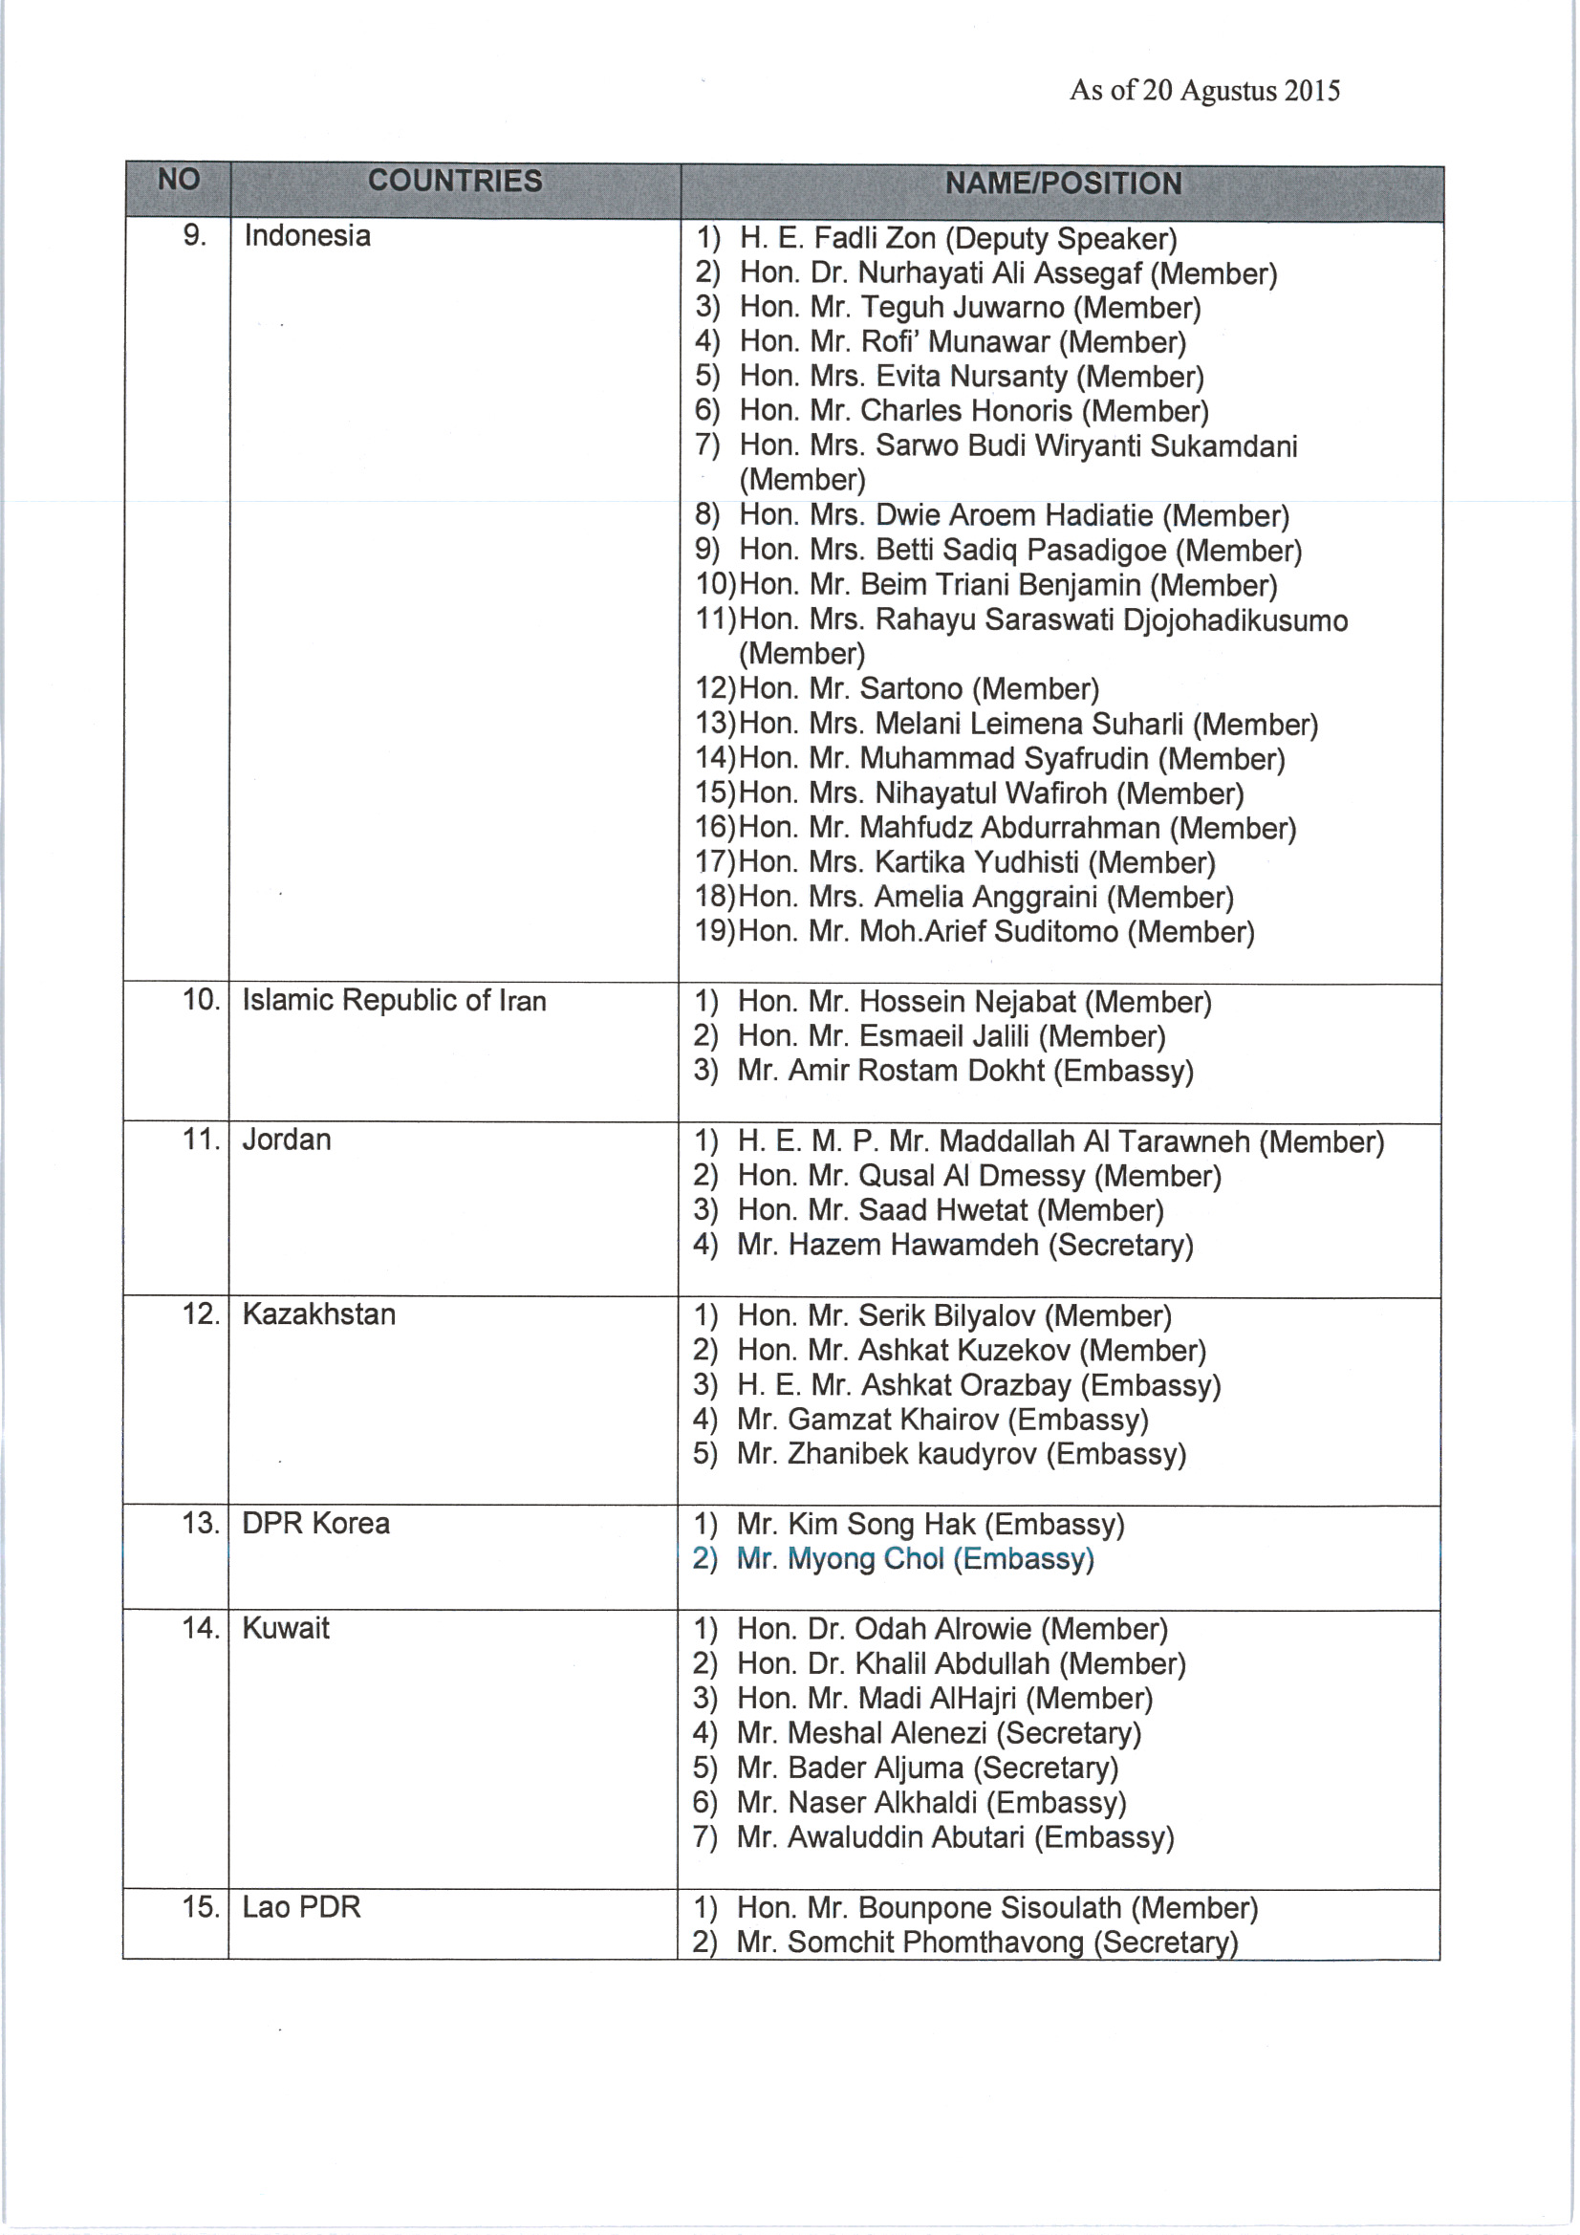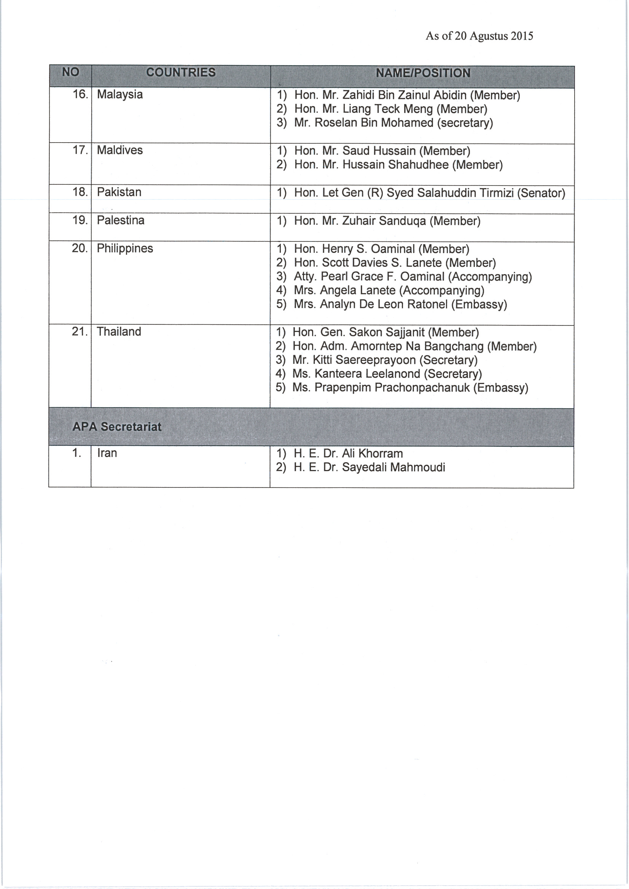
Annex II

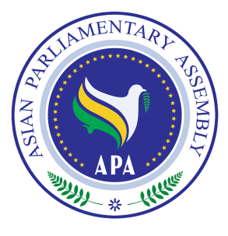

Report
of the
Secretary-General

APA Economic & Sustainable Development

Standing Committee

SG/Rep/2015/02
Jakarta, Indonesia
19 -20 August 2015

Background

The APA Plenary at its Seventh Session in Lahore decided, by its resolutions on the APA Economic & Sustainable Development Standing Committee, contained in Documents APA Resolution on Integrated Energy Market in Asia (APA/Res/2014/05); APA Resolution on Environmental Issues, Global Warming, Climate Change, and Planting Billions of Trees throughout Asia (APA/Res/2014/07) and APA Resolution on Alleviating Poverty in Asia (APA/Res/2014/08), the following:
Decide to promote the establishment of a regional cooperative relationship between West Asia and East & South Asia, aiming ultimately at a harmonized cooperation to achieve a sustainable Asian Integrated Energy Market in the continent;

Urge the Asian Parliaments to collectively address the challenges of macroeconomic instability including the establishment of a current global financial architecture and its elements;

Request the APA Member Parliaments to prevent climate change through appropriate legislations and active, systematic, identifiable measures to reduce greenhouse gas emissions;

Call on APA Member Parliaments to participate actively in the achievement of MDGs and urge Member Parliaments to encourage their governments to facilitate adoption of pro-poor economic growth policy;

1. Integrated Energy Market in Asia

The Possibility of a Regional Energy Cooperation in Asia

Asian countries own over 62% of world’s crude oil resources and 54% of world’s natural gas resources. This region also possesses 26% of world’s coal resources.
Persian Gulf countries, by having 56.6% of world’s oil resources (about 754 billion barrels) and 40.6% of world’s natural gas resources (about 76 trillion m³); claim an especially important geopolitical, geo-economic, and geostrategic position.
Asian countries produce over 42% of world’s oil, 37% of which can be attributed to Middle East countries, china and Kazakhstan. The Asian countries also produce 31% of world natural gas, 18.5% of which can be attributed to Iran, Qatar, China, Saudi Arabia, Indonesia, Turkmenistan, and Uzbekistan.
Asia produces 59% of world’s coal, 53% of which can be attributed to China, India, Indonesia and Kazakhstan.
On the other hand, Asia with an area of 30% of earth’s dry land contains 4.2 billion people. China, India, Indonesia, Pakistan, Bangladesh and Japan, are world’s most populated countries and are in Asia.
The presence of countries such as Japan, South Korea and developing countries such as China and India in Asia, mean an increasing need for energy in this continent.
In 2010, 45% of Asia’s energy needs were supplied by coal, China and India the largest users of this energy source.
Oil and gas also supplied 31% and 17%, respectively, of Asia’s energy needs; other energy forms supplied 7% of the needs.
Currently, Asian countries consume 38.7% of world’s oil, 19% of which is consumed by China, India and Japan. These countries also consume 65% of world’s coal, 54.5 of which can be attributed to China and India.

Conclusion: Asian countries are both main producers and consumers of energy. Therefore AIEM already exists in Asia to some extent.

Why Asian Integrated Energy Market?

The ultimate goal of Asian Parliamentary Assembly has been "Integration in Asia". This "Integration" should be started from somewhere;
In light of high rates of growth in energy demand in East Asia and the abundance of energy resources in West Asia, particularly 70% of the world’s oil reserve in the Persian Gulf, it is logical and recommendable to start this "Integration" from "Energy Market".
The role of energy market integration between West and East Asia will be even more important in the future due to high rate of energy consumption in the East and South of Asia.
So it is necessary to see proactive cooperation among Asian Parliaments with respect to the Asian Integrated Energy Market;

Present Obstacles

Despite South and East Asia’s increasing need for energy, and West and South-West Asia’s abundance oil and gas resources, there are some major obstacles in front of AIEM:
Technical: Middle East is the main provider of East and South Asia’s energy needs, and yet, all oil and gas export is transported by sea routes. It means, the infrastructures necessary for transfer of oil and gas to major consumers in Asia are not appropriately developed.
Political: the turbulence in the West Asia in recent years has made Asian Consumers to seek for other permanent and more secure suppliers.
Economic: The shale gas made some hope and dream in the East and South of Asia to shift from West Asia to America for oil but coming down the price of oil to less than $60 made a failure in this dream.

Questions for Asian Integrated Energy Market

What are the important global actors from an economic and political point of view in 21st century and what are their strategies concerning the energy resources in Middle East, Central Asia, Caucasia, South and East Asia?
What is the capacity of energy trade (oil, gas, coal and electricity) in APA family for 2030, especially in Middle East and Central Asia?
What are the long-term strategies of main energy producing and consuming countries in Asia?
What will be the capacity of energy transport lines (oil and gas) in APA family in 2030?
What are APA family’s strategies and policies to ensure a determining role in the region’s energy trade?
What impact will the formation of an Asian Integrated Energy Market have on maximization of member countries profits?

Model for Demand & Supply in Asia

The idea is to find a model for the development of a continental energy supply system which would be adequate to the demand for energy in Asia. One should take note of high rates of growth in energy demand in East Asia and the abundance of energy resources in West Asia, particularly 70% of the world’s oil reserve in the Persian Gulf, as an important factor contributing to the emergence and development of this model.

Asian Integrated Energy Market

It is a fact that “Asian Integrated Energy Market” will help the Asian countries to maximize the interests of both producers and consumers and minimize the risks and costs of energy in Asia;
“Asian Integrated Energy Market” can be realized if the Asian Parliamentary Assembly envisages, through cooperation among their governments, a continental energy supply system in Asia.

Role of Asian Parliaments

What do Asian Parliaments think about such market in Asia?
Do they advise their governments to support and join this market?
What kind of obstacles and difficulties do they have in their countries to join this market?
What is the Role of Asian Parliaments to support AIEM by promoting this idea through adopting the necessary legislation?

Advisory Group

“Energy Advisory Group” from appropriate Asian Parliaments together with their governments is necessary to be established as a matter of priority to provide technical advice to the Sub-Committee in order to pursue the implementation of the objectives delineated in the Plan of Action on Promotion of Asian Integrated Energy Market;
A number of issues such as energy intensity, energy conservation, and Asian Gas Network within the framework of the Asian Integrated Energy Market need to be discussed and coordinated with the Asian governmental experts so that their respective holistic views would be presented to the Sub-Committee for further consideration and decision;
As another alternative, it is proposed to realize this idea through an international conference in Asia with the participation of APA experts as well as representatives of governmental and private sectors and academic circles;
The Sub-Committee decided last year to establish the “Energy Advisory Group” but there were no enough responses from the members of the group. What would be the new decision by the Sub-Committee?

2. Environmental Issues, Global Warming, Climate Change, and Planting Billions of Trees throughout Asia

As we discussed in the AIEM Sub-committee, Asia is gradually become the main consumer of the energy in the world. It means APA should be more concerned about the environmental impact of energy consumption:
The negative environmental impact of unbridled energy consumption on a global scale and particularly in Asia is a matter of concern;
The negative and irreversible consequences of global warming on Asia should come into serious attention of Asian Parliaments;
Any improvement in energy efficiency will have significant effect on mitigating the environmental impact of the use of fossil fuels in Asia;
Energy conservation has positive impact in different economic fields and areas specially on global warming;
The United Nations is encouraging parliaments to speed up their acceptance of the second commitment period of the Kyoto Protocol, the international emissions reduction treaty, in order to provide further momentum for global climate action for the years leading up to 2020. The countdown has begun to 2015 September’s summit on the sustainable development goals, with national governments now discussing the 17 goals that could transform the world by 2030. Three of themes are directly related to environmental protection:
13) Take urgent action to combat climate change and its impacts (taking note of agreements made by the UNFCCC forum);
14) Conserve and sustainably use the oceans, seas and marine resources for sustainable development;
15) Protect, restore and promote sustainable use of terrestrial ecosystems, sustainably manage forests, combat desertification and halt and reverse land degradation, and halt biodiversity loss.

A long-term zero emissions sustainable development pathway:

Consistent with a global reduction of greenhouse gas emissions of at least 50 per cent by 2050 compared with the levels in 1990 and a continued decline in emissions thereafter, in the context of equitable access to sustainable development and a global carbon budget; a global emission budget is to be divided among all Parties according to the principles and provisions of the Convention, so as to limit global warming in this century to below 1.5 °C according to the IPCC assessment. The distribution of the global emission budget should be undertaken in accordance with historical responsibilities, ecological footprint, capabilities, and state of development.
Further to the negotiations, the Conference of the Parties (COP), invited all Parties to initiate or intensify domestic preparations for their INDCs (Intended Nationally Determined Contributions) towards achieving the objective of the Convention as set out in its Article 2, without prejudice to the legal nature of the contributions, in the context of adopting a protocol, another legal instrument or an agreed outcome with legal force under the Convention applicable to all Parties.
The forty-second sessions of the Subsidiary Body for Implementation were held from 1-11 June 2015 in Bonn, Germany. Nations concluded by elaborating the elements of the new agreement, scheduled to be agreed in Paris in September 2015, while also agreeing the ground rules on how all countries can submit contributions to the new agreement. These Intended Nationally Determined Contributions (INDCs) will form the foundation for climate action post 2020 when the new agreement is set to come into effect. During the two week 20th Conference of the Parties, countries also made significant progress in elevating adaptation onto the same level as action to cut and curb emissions. Pledges were made by both developed and developing countries prior to and during the COP that took the capitalization of the new Green Climate Fund (GCF) past an initial $10 billion target. Levels of transparency and confidence-building reached new heights as several industrialized countries submitted themselves to questioning about their emissions targets under a new process called a Multilateral Assessment. The Executive Committee of the Warsaw International Mechanism on Loss and Damage was confirmed for two years with a balanced representation of members from developing and developed countries. A work program was also established under the Committee—it has an array of actions areas, including enhancing the understanding of how loss and damage due to climate change affects particularly vulnerable developing countries.
The Multilateral Assessment showed that the number of success stories and best practices in policy and technology innovation alongside nations decoupling emissions from economic growth is increasing.

What will be the Paris Conference Achievements?

The Paris Conference is a national priority and it involves full commitment and participation of all Governments and Parliaments, at the highest level, as well as our civil society and our private sector. We have to abide by the terms of the Durban mandate: "find an agreement that helps us hold the increase in global average temperature below 2 °C or 1.5 °C above pre-industrial levels". The first component, and the most essential, is a ratify-able legal instrument applicable to all Parties which is the mission of Parliaments in Asia. The second component is the intended nationally determined contributions, which some countries have already made their views public. The third component relates to finance, technology and capacity-building. Finally, the Paris Conference will also be built on action, and more specifically, cooperative action. Asian Parliaments should actively participate in the Paris Conference to support the goals of the conference in order to control the global warming.

3. Poverty Eradication

Since the beginning, APA has paid special attention to the cause of poverty in Asia. The Millennium Development Goals (MDGs), which were agreed by governments in 2000, and are due to expire at the end of 2015, was a roadmap for eradication of poverty in Asia. There is broad agreement that while the MDGs provided a focal point for governments on which to hinge their policies and overseas aid programs to end poverty and improve the lives of poor people, they have been criticized for being too narrow. The eight MDGs – reduce poverty and hunger; achieve universal education; promote gender equality; reduce child and maternal deaths; combat HIV, malaria and other diseases; ensure environmental sustainability; develop global partnerships – failed to consider the root causes of poverty, or gender inequality, or the holistic nature of development. As the MDG deadline approaches, around 1 billion people still live on less than $1.25 a day - the World Bank measure on poverty - and more than 800 million people do not have enough food to eat. Women are still fighting hard for their rights, and millions of women still die in childbirth. The Sustainable Development Goals (SDGs) are a new, universal set of goals, targets and indicators that UN member states will be expected to use to frame their agendas and political policies over the next 15 years.

What are the proposed 17 goals?

1) End poverty in all its forms everywhere
2) End hunger, achieve food security and improved nutrition, and promote sustainable agriculture
3) Ensure healthy lives and promote wellbeing for all at all ages
4) Ensure inclusive and equitable quality education and promote lifelong learning opportunities for all
5) Achieve gender equality and empower all women and girls
6) Ensure availability and sustainable management of water and sanitation for all
7) Ensure access to affordable, reliable, sustainable and modern energy for all
8) Promote sustained, inclusive and sustainable economic growth, full and productive employment, and decent work for all
9) Build resilient infrastructure, promote inclusive and sustainable industrialization, and foster innovation
10) Reduce inequality within and among countries
11) Make cities and human settlements inclusive, safe, resilient and sustainable
12) Ensure sustainable consumption and production patterns
13) Take urgent action to combat climate change and its impacts (taking note of agreements made by the UNFCCC forum)
14) Conserve and sustainably use the oceans, seas and marine resources for sustainable development
15) Protect, restore and promote sustainable use of terrestrial ecosystems, sustainably manage forests, combat desertification and halt and reverse land degradation, and halt biodiversity loss
16) Promote peaceful and inclusive societies for sustainable development, provide access to justice for all and build effective, accountable and inclusive institutions at all levels
17) Strengthen the means of implementation and revitalize the global partnership for sustainable development
Within the goals are a proposed 169 targets, to put a bit of meat on the bones. Proposed targets under goal one, for example, includes reducing by at least half the number of people living in poverty by 2030, and eradicating extreme poverty (people living on less than $1.25 a day). Under goal five, there’s a proposed target on eliminating violence against women. Under goal 16 sits a target to promote the rule of law and equal access to justice. In his synthesis report on the SDGs in December 2014, UN secretary general Ban Ki-moon gave no hint that he would like to see the number of goals reduced. In a bid to help governments to frame the goals, Ban clustered them into six “essential elements”: dignity, prosperity, justice, partnership, planet and people.

How will the goals be funded?

That’s the trillion-dollar question. Rough calculations from the intergovernmental committee of experts on sustainable development financing have put the cost of providing a social safety net to eradicate extreme poverty at about $66bn a year, while annual investments in improving infrastructure (water, agriculture, transport, power) could be up to a total of $7tn globally.
In its report last year, the committee said public finance and aid would be central to support the implementation of the SDGs. But it insisted that money generated from the private sector, through tax reforms, and through a crackdown on illicit financial flows and corruption was also vital.

When will the new goals come into force?

If member states agree the draft set of 17 SDGs at a UN summit in New York in September 2015, they will become applicable from January 2016. The expected deadline for the SDGS is 2030. The countdown has begun to September’s summit on the sustainable development goals, with national governments now discussing the 17 goals that could transform the world by 2030.

Is it realistic and practical to achieve such goals?

It is hard to say this annual $70bn project could come to the reality but APA parliaments should do their best to support this program from one side and fulfill their own national planning for eradication of poverty. The first thing needed if we’re to get people out of poverty is more jobs that pay decent wages. There aren’t enough of these in our current economy. We’ll need a full-employment policy and a bigger investment in 21st-century education and skill development strategies if we’re to have any hope of breaking out of the current poverty malaise in Asia.

4. Financial Affairs: Ensuring efforts for Economic Growth

Since 2008, the Asian governments have been forced by the turbulent and inhospitable global economic environment to navigate their economies through the most severe and sustained global economic crisis in our history. In response, Asian Governments mostly rolled out a short-term development strategy to achieve economic stabilization, adjustment and growth. To the extent that any real growth prospects were dependent on the upturn in the global economy, the protracted nature of the global downturn led to the postponement of any significant real growth. Asian governments were however successful in keeping their economies stable by maintaining a comfortable level of foreign exchange reserves, securing jobs and maintaining a comfortable social safety net. This development strategy recognizes, as a point of departure, the need and urgency to jumpstart and sustain private sector and investment led, productivity and export driven growth based on an environmentally green and socially sustainable and equitable economy while radically adjusting and reforming the Asian economy. While seeking to broadly achieve sustainable growth and development, the framework took implicit and explicit cognizance of the need to ensure environmentally efficient resource use in the context of a green economy in Asia. The main efforts were based on the returning the Asian economy to a sustainable growth rate of 3 to 4 per cent while maintaining macroeconomic stability; facilitating broad based adjustments and reforms in the Asian economy; enhancing social and human development and; enhancing energy and environmental sustainability in the context of the green economy. This growth must be managed in a way that was environmentally and fiscally sustainable, would generate employment opportunities (labor intensive growth) and would ensure that the fruits of economic growth contribute to poverty alleviation in an equitable manner.
A developed Asian economy is characterized by increased capital resources, improved in efficiency of labor, better organization of production in all spheres, developed transport and communication infrastructure, growth of banks and other financial institutions, urbanization and a rise in the level of living, improved standards of education and expectation of life, greater leisure, more recreation facilities and the widening of the mental horizon of the people, and so on. In short, economic development must break the poverty barrier or the vicious cycle and bring into being a self-generating green economy so that economic growth becomes self-sustained.
The incipient recovery is expected to continue and become more robust in 2015 and 2016. At the same time, the first signs of rebalancing in the Asian economy are visible and a number of important macroeconomic imbalances are being corrected. It is vital to keep the momentum and continue with the implementation of agreed measures and reforms at APA and national level to ensure sustainable economic growth, high level of employment, stable public finances and financial stability. Furthermore, the deleveraging needs in the public and private sector, fragmentation of financial systems and credit markets, sectoral adjustments and high unemployment will continue to weigh on the economic growth in the coming years. Asian countries have also made a positive contribution towards the global effort to achieve several of the United Nations Millennium Development Goals (MDG’s).

Annex III
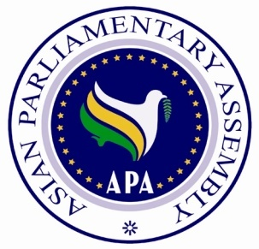
Asian Parliamentary Assembly

SC-Economic / Draft Res/2015/05
20 August 2015

Draft Resolution on
Financial Affairs: Ensuring Efforts for Economic Growth

We, the Members of the Asian Parliamentary Assembly,

Recalling APA resolution on the Ramification of International Financial Crisis for the Economies of Countries of APA Member Parliaments, APA/Res/2013/13, APA/Res/2013/06 and other relevant APA resolutions;

Expressing concern with the following repercussions of the sovereign defaults and financial markets volatility to the economic growth in APA countries;

Taking note on the deliberations at the UN, G-20, IMF, WTO, WB, ADB and other international organizations and their recommendations towards a global economic slowdown to redress the situation;

Appreciating the measures that have already been taken by Asian Parliaments and their governments to contain the negative impacts of economic crisis in their economies, and expect them to take further steps to stimulate their respective economies;

Noting that the economic growth in Asian Economies has not been shared equally in the society whereby the Gini Coefficient, as reported by the Asian Development Bank, had grown significantly over the last decades and that regional cooperation which have already existed in Asia could serve as a platform for enhancing cooperation among sub regional economic organization that would improve welfare for all in Asia;

Noting that peace and stability in the region is an important contributor to economic growth and that violence and political instability act as inhibitors for economic development and that maintaining regional collaboration on political stability is crucial;

Recognizing also the necessity to effectively reform the current global financial architecture so as to achieve a more balanced world economic and financial order;

We therefore,

- Call upon Asian governments to take new policy approaches to develop a more comprehensive and innovative growth strategies needed to sustain a more resilient, balanced and sustainable economic growth as a sole means to create decent jobs and reduce inequalities.
- Call upon APA member parliaments to support the development of Asian-led multilateral banks and its capacity to promote equitable economic growth, improve national and trans-boundary connectivity and to seek possible establishment of a regional stabilization fund in times of economic crisis;
- Encourage APA member governments to create a protocol to enhance resilience to economic crisis which regulates the allocation for some budget reserves for economic crisis mitigation;
- Also encourage governments in Asia to promote cross-border private investments while ensuring an institutional capacity and prudent regulatory framework to enable countries to absorb large capital flows, while at the same time using bilateral swap arrangement to promote the role of local currency in financing cross-border trade;
- Recommend parliaments in APA member countries to improve the fiscal policies, especially the tax system in order to expand tax collection;
- Also recommend government in APA member countries to promote the adoption of Basel III to improve supervision on financial sector governance;
- Encourage parliaments in APA member countries to focus on policies that alleviate poverty, including improving access to health, education and social protection to help close income inequality;
- Call for parliaments in respective countries to review its legislations, where appropriate, to give more support to small and medium enterprises (SMEs) by giving access to low interest credit loan and to provide capacity building and regional networking to integrate SMEs into regional and global value chains;
- Encourage parliaments to support financial inclusion for the poor in each respective country and to share best practices of financial inclusion in the region;
- Stress the importance to invest in human development and to provide sufficient public funding for education and health for everyone, without gender bias, to face the future global economy demands;
- Request the government in respective countries to channel more funds in joint research and development (R&D) activities as a means to spur innovation and viable economic growth strategies to sustain a more resilient economic growth;

- Also request the government in respective Asian countries to promote the implementation of low carbon economy despite the global economy deceleration;
- Call upon the APA Member Parliaments to continuously promote the need for reform in global financial institutions and architecture, with the view for a balanced world economic and financial order;
- Call upon APA member countries to strive to create an enabling institutional and business environment that can promote financial stability, financial inclusion, and efficient mobilization and utilization of the available resources;
- Call upon APA member countries to facilitate and promote investing their sovereign funds and encourage their private investors to invest in Asia rather than other parts of the world.

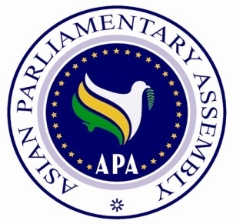

SC-Economic / Draft Res/2015/06
20 August 2015

Draft Resolution on
The Role of APA Parliaments to Adopt Legislation in
Supporting the Implementation of the
Sustainable Development Goals

We, the Members of the Asian Parliamentary Assembly,

Acknowledging the (zero draft of the) outcome document for the UN Summit to adopt Post-2015 Development Agenda entitled “Transforming our world by 2030: A new agenda for global action,” adopted in September 2015;

Referring to the Inter-Parliamentary Union (IPU) Hanoi Declaration on The Sustainable Development Goals: Turning Words into Action, adopted at its 132nd Assembly, held in Hanoi, Vietnam, March 2015; the Surabaya Declaration adopted at the Parliamentary Event on MDGs Acceleration and Post-2015 Development Agenda held in Surabaya, Indonesia on 12-13 November 2014; and other relevant inter-parliamentary organizations resolutions;

Being convinced that the SDGs are integrated and indivisible, global in nature and universally applicable, taking into account the principle of common but differentiated responsibilities, capacities, levels of development, and respecting national policies and priorities;

Underlining the strong political will, leadership and national ownership of the parliament to meet the international commitment of the SDGs and that the role of parliament is essential in improving economical, social, cultural and ecological to improve the human development and promote the Human development Index as an index for the sustainable development goals. Set up the consensus for the government, parliament and people to recognize the efficiency of the development particularly in the areas of health, education, housing, food security, nutrition and environmental sustainability;

We, therefore:

- Endorse the outcome document of the UN Summit to adopt Post-2015 Development Framework which adopting the SDGs as the new development framework for 2015-2030. The list of the SDGs is annexed;

- Determine to be actively involved in the formulation of national policies to support the mainstreaming and implementation of SDGs;

- Call upon APA Members to provide adequate budgetary resources and adopt legislations which are relevant to support and monitor the successful implementation of the SDGs;

- Strengthen the national ownership of SDGs by actively involved in the advocacy of SDGs so that the people understand that SDGs are relevant to their lives;

- Request the Standing Committees of APA to deliberate in a comprehensive manner issues of SDGs which are relevant to the work of their committees;

- Stress the importance to develop data and indicators to set up a proper follow-up mechanism on the implementation of SDGs and the need to strengthen statistical capacities of all countries to support the progress;

- Request the Asian Parliament to report the achievement of the implementation of the SDGs to the APA Secretary General for the information and discussion in the next Economic and Sustainable Development Standing Committee.

Sustainable Development Goals
Goal 1 | End poverty in all its forms everywhere
Goal 2 | End hunger, achieve food security and improved nutrition and promote sustainable agriculture
Goal 3 | Ensure healthy lives and promote well-being for all at all ages
Goal 4 | Ensure inclusive and equitable quality education and promote lifelong learning opportunities for all
Goal 5 | Achieve gender equality and empower all women and girls
Goal 6 | Ensure availability and sustainable management of water and sanitation for all
Goal 7 | Ensure access to affordable, reliable, sustainable and modern energy for all
Goal 8 | Promote sustained, inclusive and sustainable economic growth, full and productive employment and decent work for all
Goal 9 | Build resilient infrastructure, promote inclusive and sustainable industrialization and foster innovation
Goal 10 | Reduce inequality within and among countries
Goal 11 | Make cities and human settlements inclusive, safe, resilient and sustainable
Goal 12 | Ensure sustainable consumption and production patterns
Goal 13 | Take urgent action to combat climate change and its impacts*
Goal 14 | Conserve and sustainably use the oceans, seas and marine resources for sustainable development
Goal 15 | Protect, restore and promote sustainable use of terrestrial ecosystems, sustainably manage forests, combat desertification, and halt and reverse land degradation and halt biodiversity loss
Goal 16 | Promote peaceful and inclusive societies for sustainable development, provide access to justice for all and build effective, accountable and inclusive institutions at all levels
Goal 17 | Strengthen the means of implementation and revitalize the global partnership for sustainable development
*acknowledging that the United Nations Framework Convention on Climate Change is the primary international, intergovernmental forum for negotiating the global response to climate change

Asian Parliamentary Assembly

Draft Resolution on
Asian Integrated Energy Market
SC-Economic / Draft Res/2015/07
20 August 2015

We, the Members of the Asian Parliamentary Assembly,

Recalling APA Resolution on Integrated Energy Market in Asia (APA/Res/2014/05) adopted at the 7th APA Plenary in Lahore, Pakistan, December 2014 and other relevant APA resolutions;
Welcoming the Report of the Secretary-General on the Asian Integrated Energy Market (AIEM), to the meeting of the Energy Sub-Committee held in Jakarta, Indonesia, on 20 August 2015;
Considering the role of energy market integration between West and East Asia that will be even more important in the future due to high rate of energy consumption in the East and South of Asia.

Concerning about the turbulence in the West Asia in recent years as a real obstacle in front of Asian Integrated Energy Market;
Recognizing that “Integrated Asian Energy Market” can help the Asian countries to maximize the interests of both producers and consumers and minimize the risks and costs of energy in Asia;

Emphasizing the need to develop multilateral co-operation among Asian countries and the work of APA to develop an Integrated Energy Market in Asia as efforts to provide a sustainable, green and clean energy as they are crucial for the climate change mitigation and the attainment of the Sustainable Development Goals;

Reaffirming the importance of adoption and implementation of environmentally sound energy policies and projects throughout Asia;

Welcoming the decreasing trend of energy intensity in the most regions of the world and in particular in Asia;
Welcoming the Asian governments’ commitments to reduce carbon emissions affecting global warming and environmental cleanness;

We, therefore;

- Decide to expand the mandate of the Advisory Group on Energy not only to link the demand and the supply for energy in Asia but also to promote the sustainable use of energy, in line with the spirit enshrined in the UN Summit 2015 Declaration in order to secure our planet for present and future generations;

- Call upon APA Member Parliaments to encourage their respective governments to scale up bilateral and multilateral cooperation among Asian countries on energy-related issues to further develop energy cooperation and its sustainability and to be linked such efforts with those existing international commitments such as the SDGs and the UN Framework Convention for Climate Change (UNFCCC);

- Urge again all Members of Parliaments to report to the Secretary-General on their national experiences in the field of increasing energy efficiency as outlined in Paragraph 33 of the Secretary-General’s Report contained in SG/Rep/2008/01/Rev.1 dated 10 May 2008;

- Request also the Secretary-General to seek the views of Member Parliaments on the implementation of this resolution and to report thereon to the next meeting of the Standing Committee;

- Decide to extend the mandate of the Sub-Committee to promote the development of the Asian Integrated Energy Market.

Asian Parliamentary Assembly

Draft Resolution on
Environmental Issues, Global Warming, Climate Change, and Planting Billions of Trees throughout Asia
SC-Economic / Draft Res/2015/08
20 August 2015

We, the Members of the Asian Parliamentary Assembly,

Recalling APA Resolution on Environmental Issues, Global Warming, Climate Change, and Planting Billions of Trees Throughout Asia (APA/Res/2014/07) adopted at the 7th APA Plenary in Lahore, Pakistan, December 2014 and other relevant APA resolutions;
Welcoming the Report of the Secretary-General on Environmental Issues, Global Warming, and Planting Billions of Trees throughout Asia, contained in document SG/Rep/2011/03-2 dated 31 July 2015;
Recognizing the need to pursue the components of sustainable development namely the economic growth, social development and environmental protection in a balanced and mutually supportive manner;
Highlighting the link between sustainable development and other relevant ongoing processes such as the UN Framework Convention on Climate Change (UNFCCC), the Convention on Biological Diversity and the International Conference on Financing for Development among others;
Underlining the necessity of a comprehensive and long-term strategy to combat desertification, thus improving the living conditions of the people living in arid and semi-arid areas;
Recognizing the significance of exchanging information on environmental issues among Asian countries and transfer of environmental technology, in particular scientific and technical assistance, from those countries with high capabilities in the area of sustainable development to less developed countries in Asia;
Concerning about the negative environmental impact of unbridled energy consumption on a global scale and particularly in Asia;

Encouraging Asian parliaments to speed up their acceptance of the second commitment period of the Kyoto Protocol, in order to provide further momentum for global climate action for the years leading up to 2020;

Supporting the global reduction of greenhouse gas emissions of at least 50 per cent by 2050 compared with the levels in 1990, in the context of equitable access to sustainable development, so as to limit global warming in this century to below 2 °C or 1.5 °C;

Recognizing the responsibility of developed countries and international institutions to meet the special needs of Asian countries, particularly Asian developing countries, in their efforts to deal with negative consequences of environmental degradation effectively and reiterating the importance of devising a proper mechanism for technology transfer and financing environmentally sound technology from developed to developing countries;
Emphasizing that substantive involvement of APA in the latest state of affairs as regards the ongoing negotiations within the context of UNFCCC and Kyoto Protocol, exchange of views among Member Parliaments and striving for bringing as much coordination and collaboration as possible in relevant negotiating fora with a view to serving and improving the common regional interest of Asia is a compelling imperative;
Encouraging the inclusion of Asian parliamentarians in the national delegations participating in the climate change negotiations in Paris in December 2015;
Emphasizing the importance of cooperation among Member Parliaments with regard to efforts to combat desertification;
1. Invite APA developed members to assess how loss and damage due to climate change affects the world particularly vulnerable developing countries in Asia;
2. Ask APA Member Parliaments to facilitate the conclusion of an agreement that addresses in a balanced manner to hold the increase in global average temperature below 2 °C or 1.5 °C above pre-industrial levels;
3. Urge APA Parliaments to support Sustainable Development Goals with regard to environmental issues by adopting appropriate legislation;

4. Invite the APA Member Parliaments to proceed with legislation and other legal actions deemed appropriate and facilitative to encouraging the governments to formulate and implement legislations, policies and measures with regard to the following:
• Integrating climate policies in broader development policies with a view to making implementation and overcoming barriers easier;
• Financing and encouraging R&D for low carbon or cleaner technologies with a view to stimulating technological advances, reduce costs, and enable progress toward stabilization;
• Legalizing the necessity of observing the Environment Impact Assessment (EIA) as a step towards bringing a balance between the three pillars of sustainable development namely: economic growth, social development and environmental protection;
• Encouraging the maximum possible interaction, coordination, integrity and solidarity among Asian delegations involved in climate change negotiations with a view to providing for a collective wisdom by Asia as their common interests which in turn shall strengthen Asian regionalism and contribute to the cause of an Asian integration;
• Interacting with and make collective attempts with other Asian States Parties for pushing the environmental priorities and urgencies of the Asia within the agenda of financial and technological mechanisms of environment related instruments such as Global Environmental Facility (GEF), those operating within UNEP and the newly established technological and financial mechanisms in Durban in 2011;
5. Recommend the holding of APA coordination meetings of Member Parliaments in the sidelines of Paris event to enable the Members interact, assess the possibilities of better coordination and better understanding the legislation challenges and opportunities as regards the draft agreements under negotiation and also as concerns the collective efforts within the APA;
6. Invite APA Member Parliaments to exchange experiences and best practices on environmental issues and provide, on a voluntary basis, the data and information concerning issues related to sustainable development, climate change and other environment related major issues to the Secretariat to be compiled in a database for the reference and use by all Member Parliaments;
7. Invite also APA Member Parliaments, in a position to do so, to provide material and technical support to APA members in their efforts to combat desertification;
8. Request the Secretary General to seek the views of APA Member Parliaments on the implementation of the present resolution and report thereon to the next session of the Standing-Committee in 2016.
9. Call on parliamentarians from APA to urge their respective government to publish Intended Nationally Determined Contributions (INDC) before COP-21.

Asian Parliamentary Assembly
Draft Resolution on Poverty Eradication
SC-Economic / Draft Res/2015/09
20 August 2015

We, the Members of the Asian Parliamentary Assembly,

Recalling APA Resolution on Alleviating Poverty in Asia (APA/Res/2014/08) adopted at the 7th APA Plenary in Lahore, Pakistan, December 2014 and other relevant APA resolutions;

Welcoming the report of the Secretary-General on Alleviating Poverty in Asia, SG/Rep/2015/03-1 dated 31 July 2015;
Underlining the significance of the role of Parliaments both in advocating and over sighting to achieve Sustainable Development Goals (SDGs), especially on Poverty Eradication;
Welcoming the High-level Plenary meeting of the U.N. General-Assembly on the Sustainable Development Goals in September 2015 and its outcome;
Reaffirming that each country must take primary responsibility for its own development and that the role of national policies and strategies cannot be overemphasized in the poverty eradication;
Noting that poverty alleviation is important to combat international terrorism and drug trafficking, arms smuggling, human trafficking, sea piracy and transnational crimes;

Taking note of the positive progresses attained by countries through the global acknowledged development framework of Millennium Development Goals (MDGs) and that MDGs have raised awareness of ending global poverty as an urgent challenge and a priority for global action while at the same time, the MDGs shortcomings need to be addressed in a fully manner under the definition of the post-2015 framework;

Mindful of the fact that the sustainable development recognizes that poverty eradication, fighting inequality, preserving the planet and creating inclusive economic growth are linked to each other and interdependent and that the SDGs balance all the three crucial sustainable development dimensions: the economic, the social and the environmental;

Reaffirming that poverty is the greatest global challenge facing the world today and an indispensable requirement for sustainable development;

Supporting also a publicity campaign to raise awareness in the society about SDG's goals utilizing the potentials of mass media;

Acknowledging any act of aggression and injustice that hinder development and any efforts aiming at promoting poverty which have been implemented by any party including Israel as occupying power are against the United Nations Charter and Sustainable Development Goals.
1. Call on APA Member Parliaments to participate actively in the achievement of MDGs and urge Member Parliaments to encourage their governments to facilitate adoption of pro-poor economic growth policy;
2. Urge APA Member Parliaments to work closely with their governments in the formulation and implementation of the measures which are outlined in the High Level Plenary meeting of the General-Assembly on the Sustainable Development Goals;
3. Invite Member Parliaments to adopt necessary legislation to a) improve labour market regulations, b) support the informal sector and offering increased security to it, c) establish legal savings and loan associations that can help to reduce the reliance on moneylenders, d) promote urban agriculture which contributes essentially to reduction of poverty in urban areas, e) empower the urban poor to improve their living conditions and participate in decision-making which affects their lives, f) help to upgrade the infrastructure and services in areas where the urban poor live and work and to provide better education for urban poor particularly for girls and g) improve disaster preparedness, disaster relief as well as post-disaster economic recovery;
4. Determine to be more ambitious in our efforts to eradicate poverty, reduce inequality, ensure food security, access to healthcare and education;

5. Urge APA Member Parliaments to redouble their efforts in supporting activities of poverty eradication and encourage their respective governments to facilitate the implementation of effective policies to promote sustained, inclusive and sustainable economic growth, full and productive employment and decent work for all;

6. Call on Member Parliaments to submit a report on their best practices and those of their executive branches to the APA Secretariat to be placed on the APA website;
7. Encourage Member Parliaments to take joint action to organize aid campaigns, on a voluntary basis upon the request of a Member Parliament, for assistance in the context of alleviating poverty;
8. Request the Secretary-General to seek the views of Member Parliaments on their efforts to implement this resolution and to submit a report thereon to the next meeting of the Standing-Committee in 2016.

The paragraph is included under the assumption that the Standing Committee on Economic and Sustainable Development meeting in Jakarta will adopt a draft resolution to be submitted for its approval in the second reading at the next Standing Committee meeting scheduled to be held at the sideline of the APA Plenary in December, 2015.
Thailand also proposed " Sufficiency Economy Philosophy", a project apparently with similar content
The list of the SDGs needs to be updated with the adopted version of SDGs (September 2015). The present list of SDGs is attached from the zero draft of the outcome document for the UN Summit to adopt the Post-2015 Development Agenda.
Transforming Our World: the 2030 Agenda for Sustainable Development, finalized text for adoption (1 August), page 12, https://sustainabledevelopment.un.org/post2015/transformingourworld, retrieved by 14 August 2015.

